**Assignment 3 – Report for P1 and P2**

Mingzhen JIANG 21108128

**P1**

***Testing for Q1:***

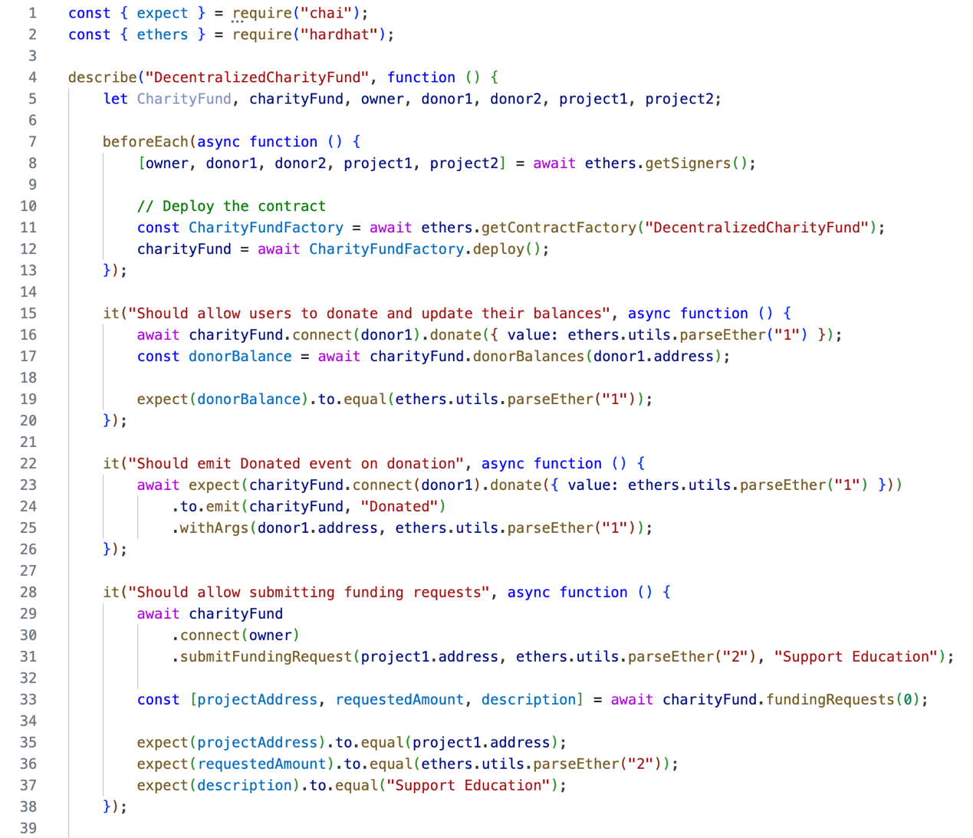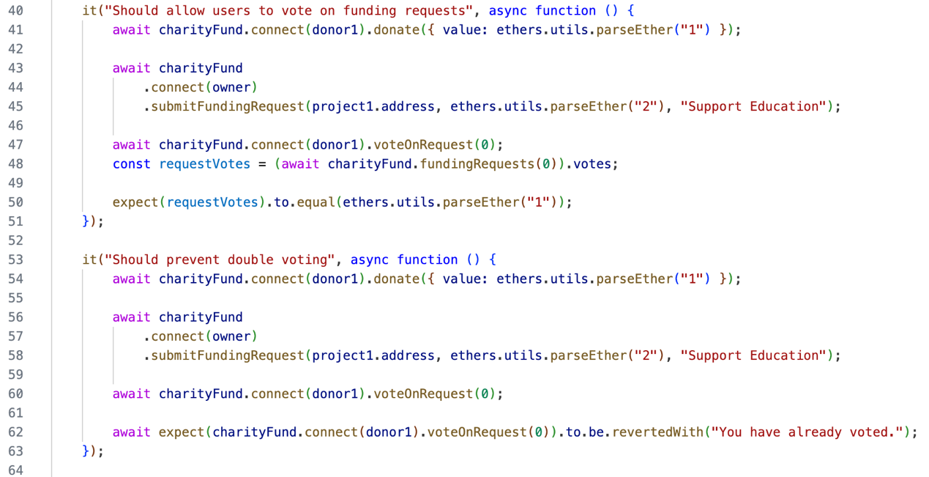

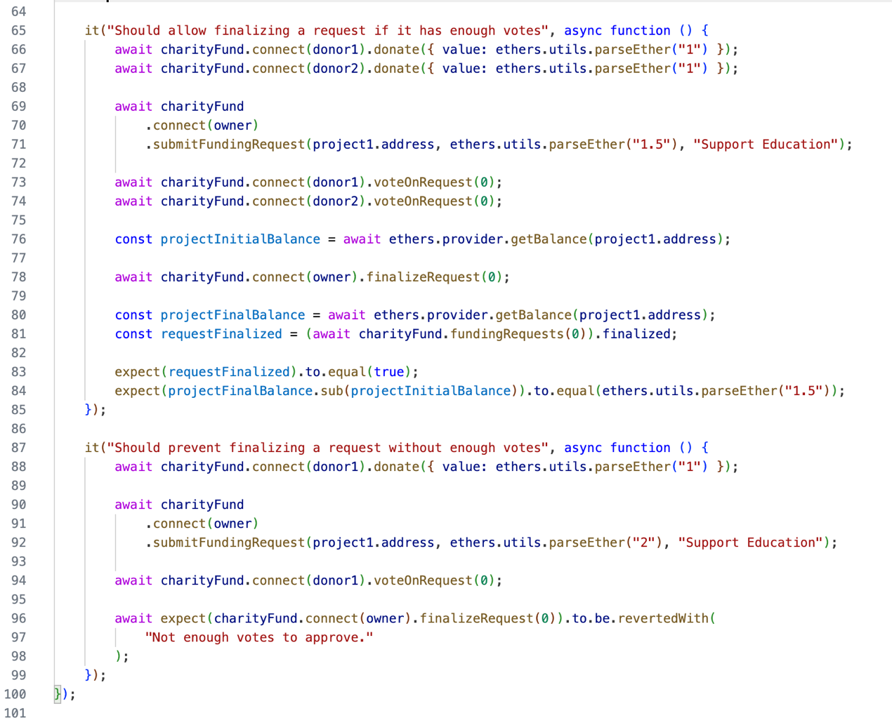

***Testing result for Q1:***

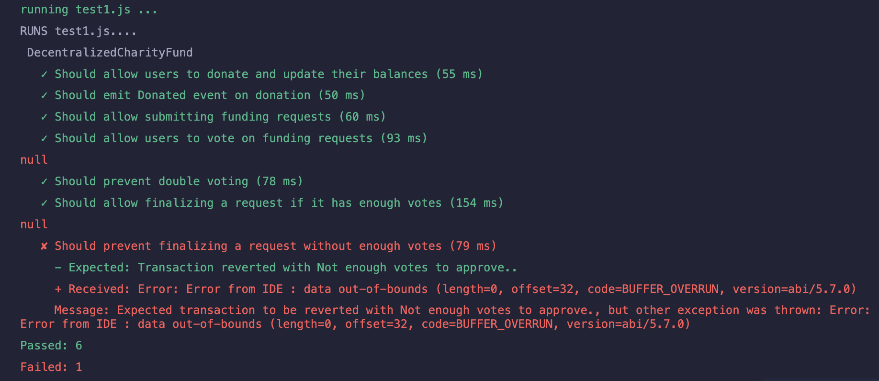

Solidity analyzers are used to verify DecentralizedCharityFund contract for vulnerabilities: 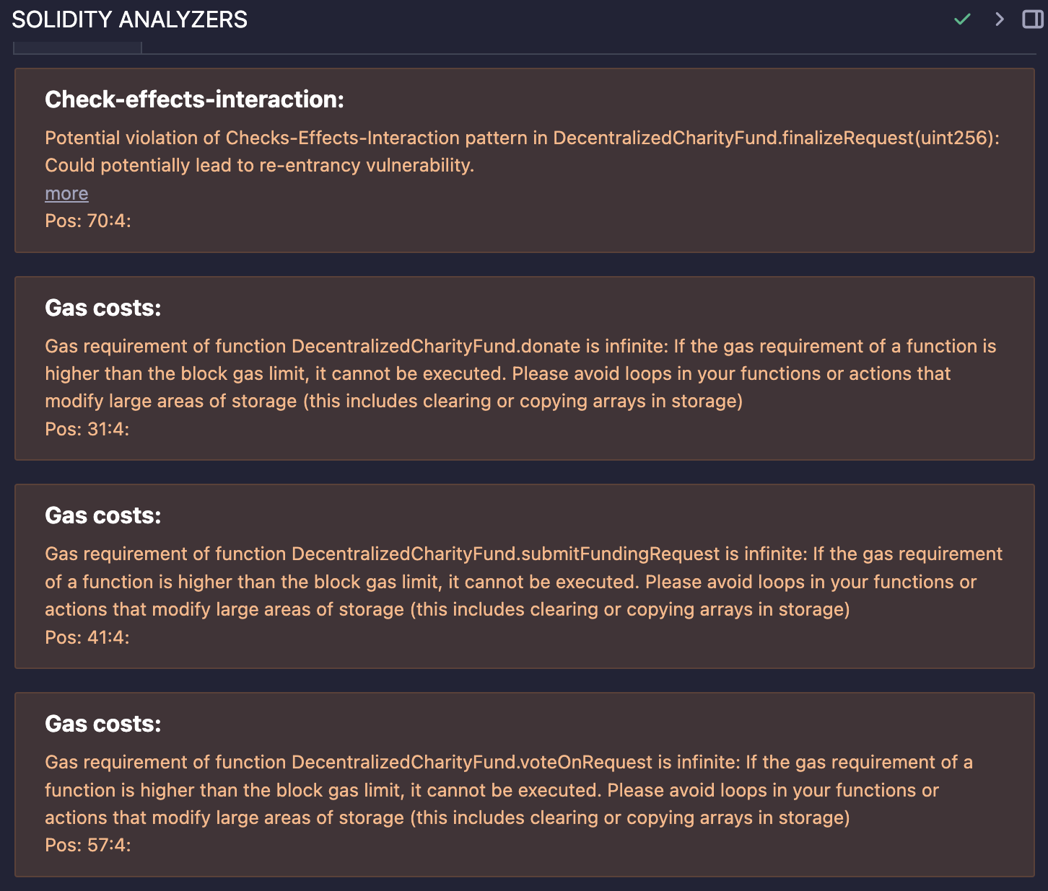

After deployment, the verified contract address: <https://sepolia.etherscan.io/address/0x870f80823772b3Ef098844A852dDfBeec1061776>

***Testing for Q2:***

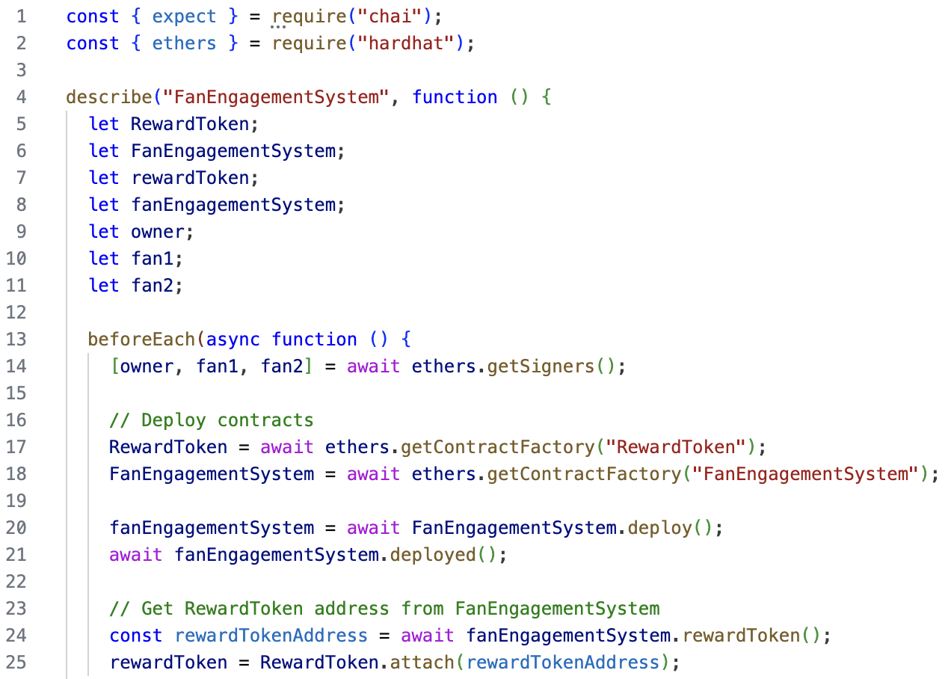

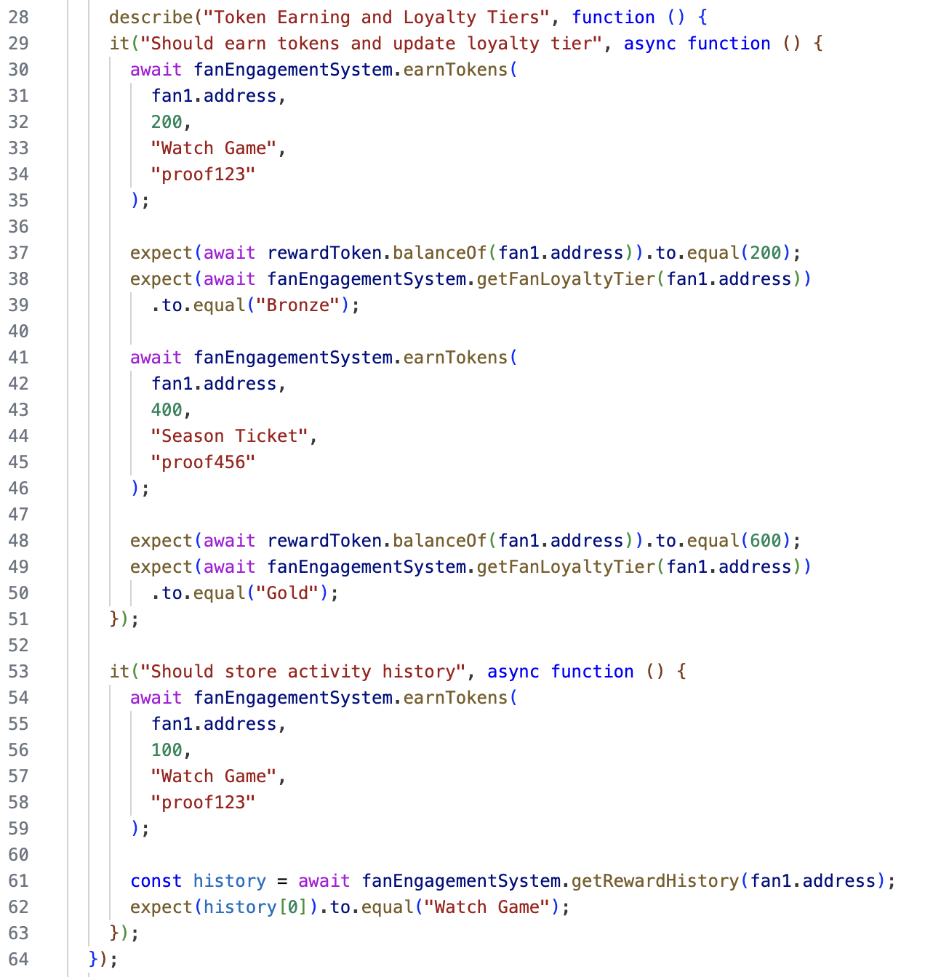

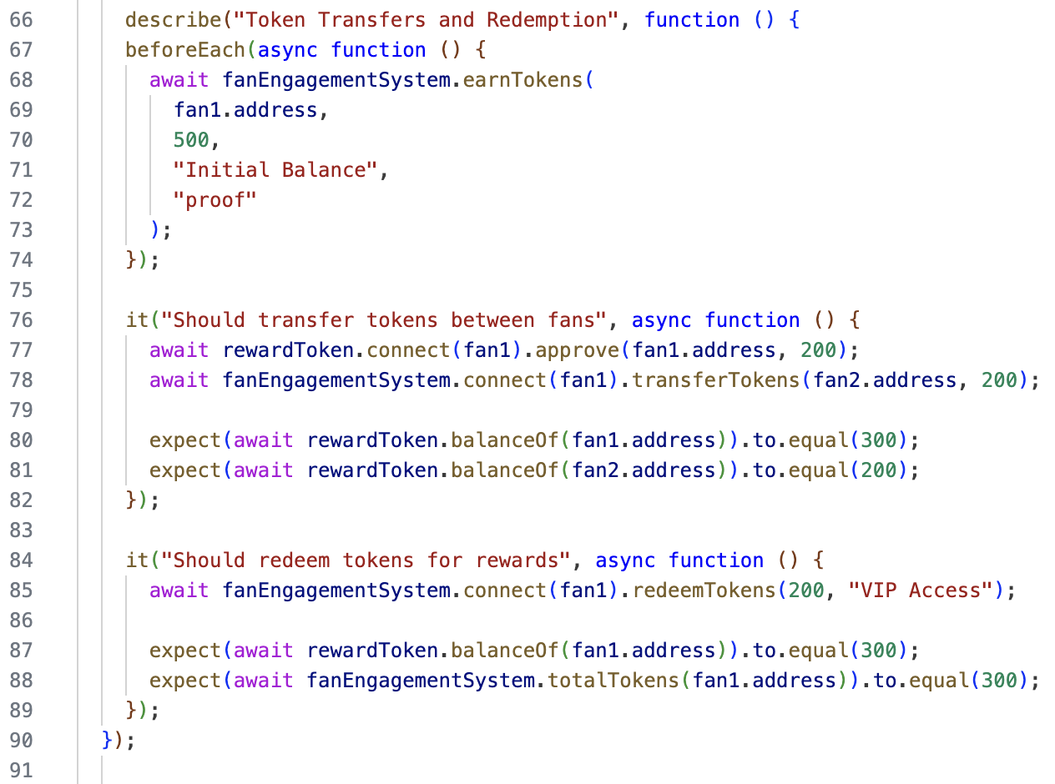

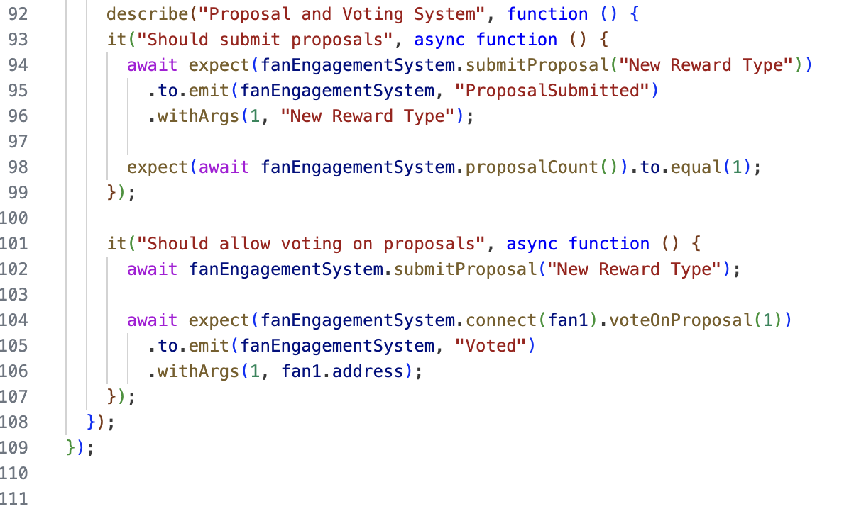

***Testing result for Q2:***

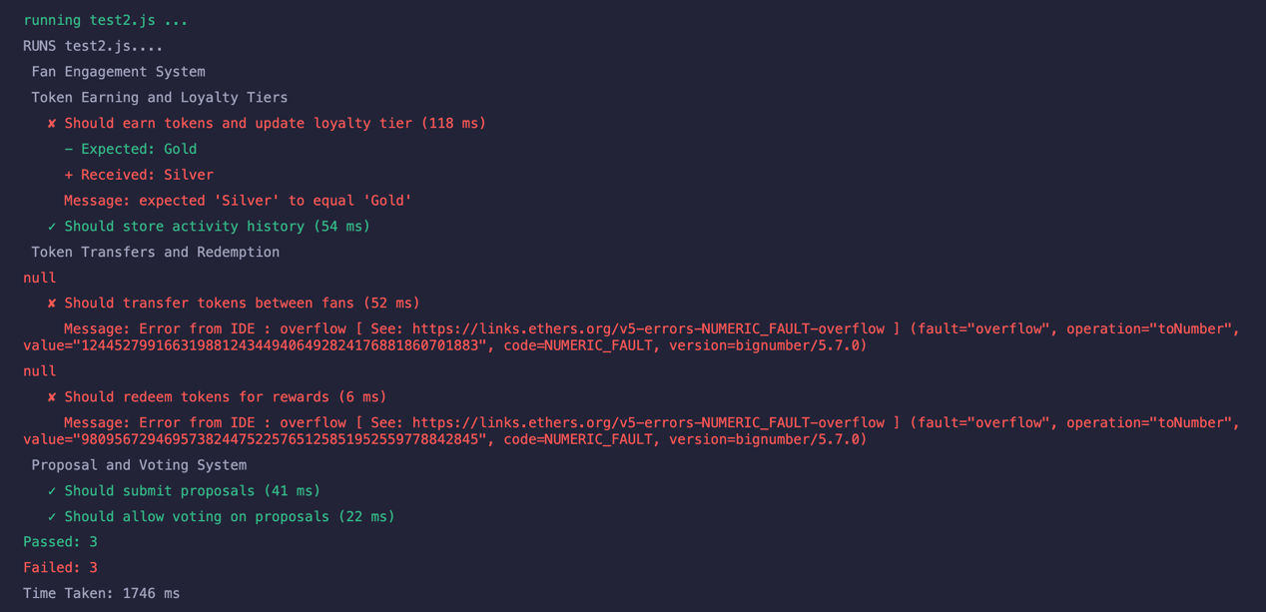

Solidity analyzers are used to verify FanEngagementSystem contract for vulnerabilities:

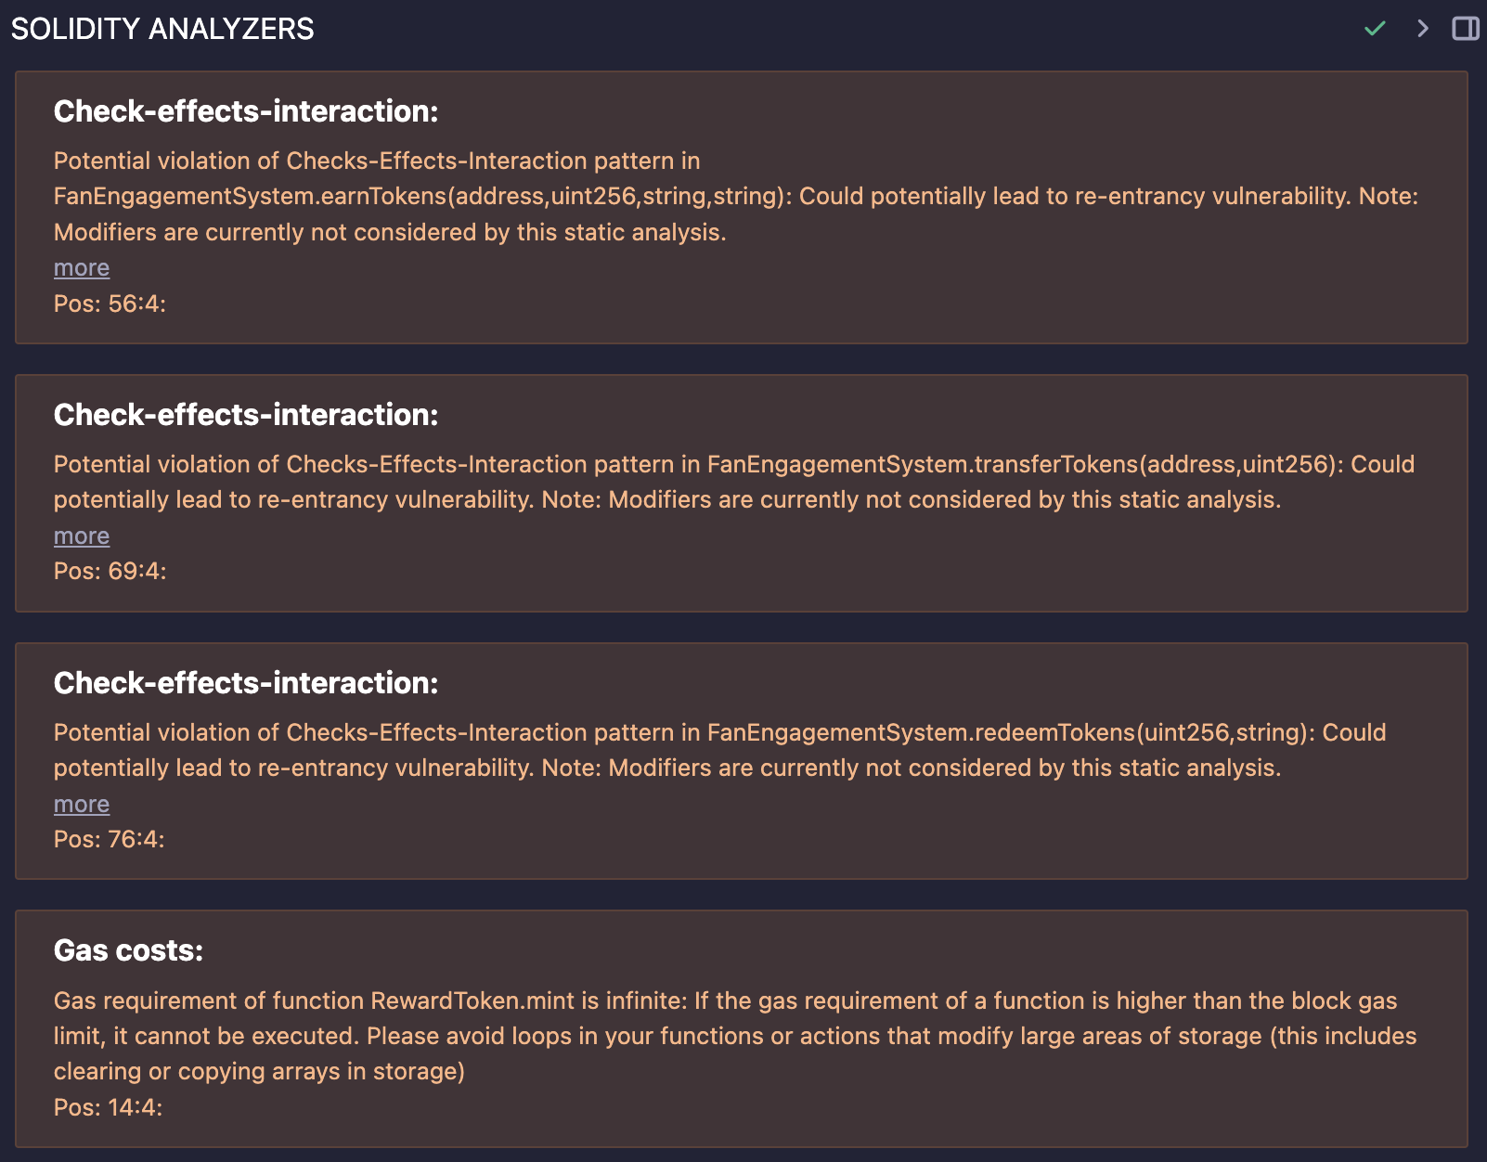

After deployment, the verified contract address:

[**https://sepolia.etherscan.io/address/0xF4EF13a0c667B0dF23197106Df29ffBd491ddd0B**](https://sepolia.etherscan.io/address/0xF4EF13a0c667B0dF23197106Df29ffBd491ddd0B)

***Testing code for Q3:* 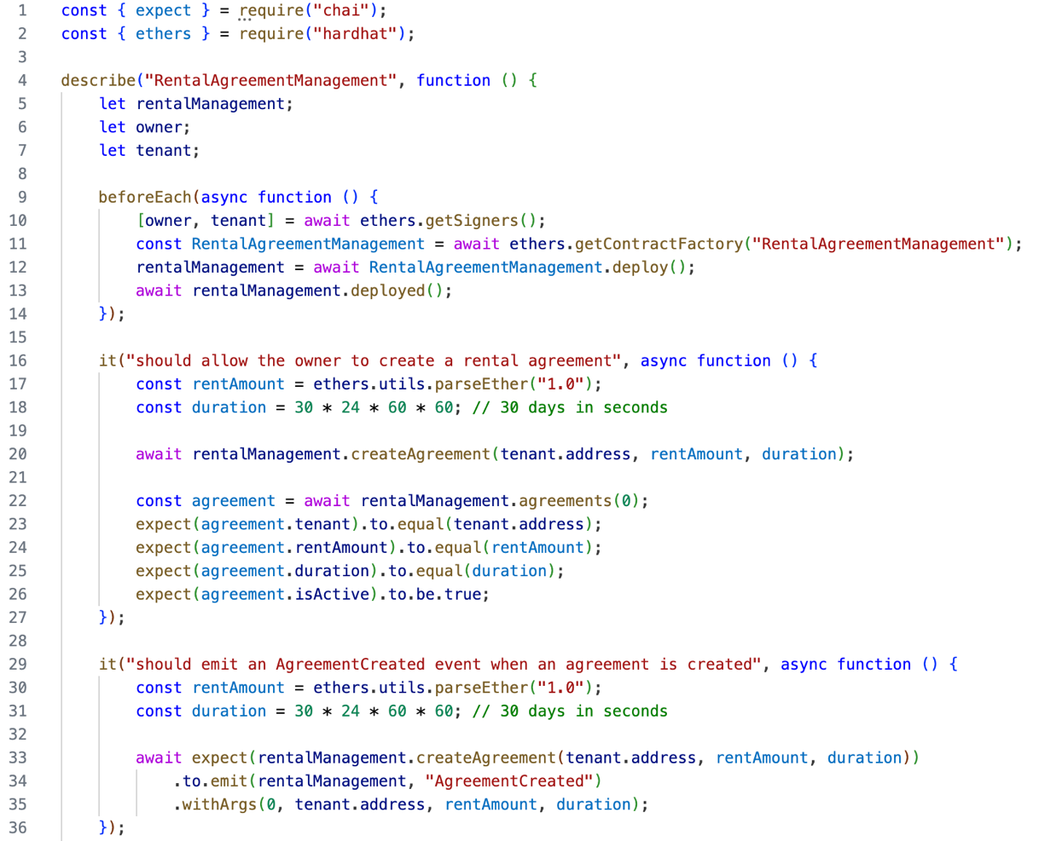**

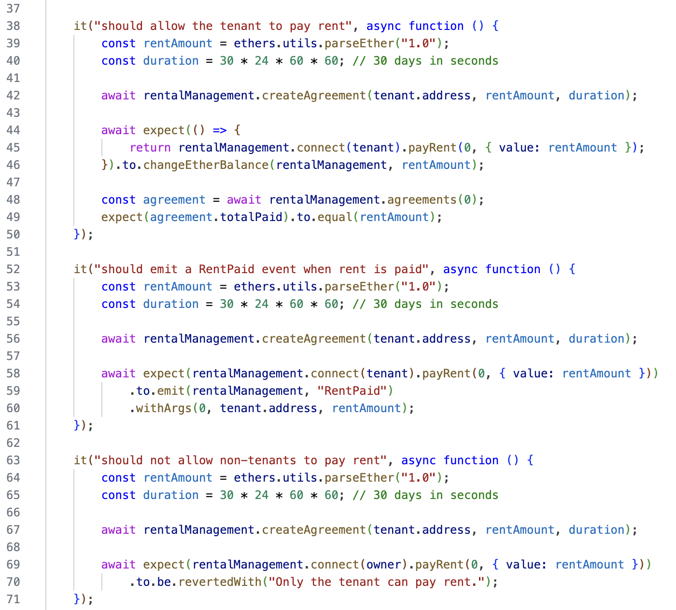

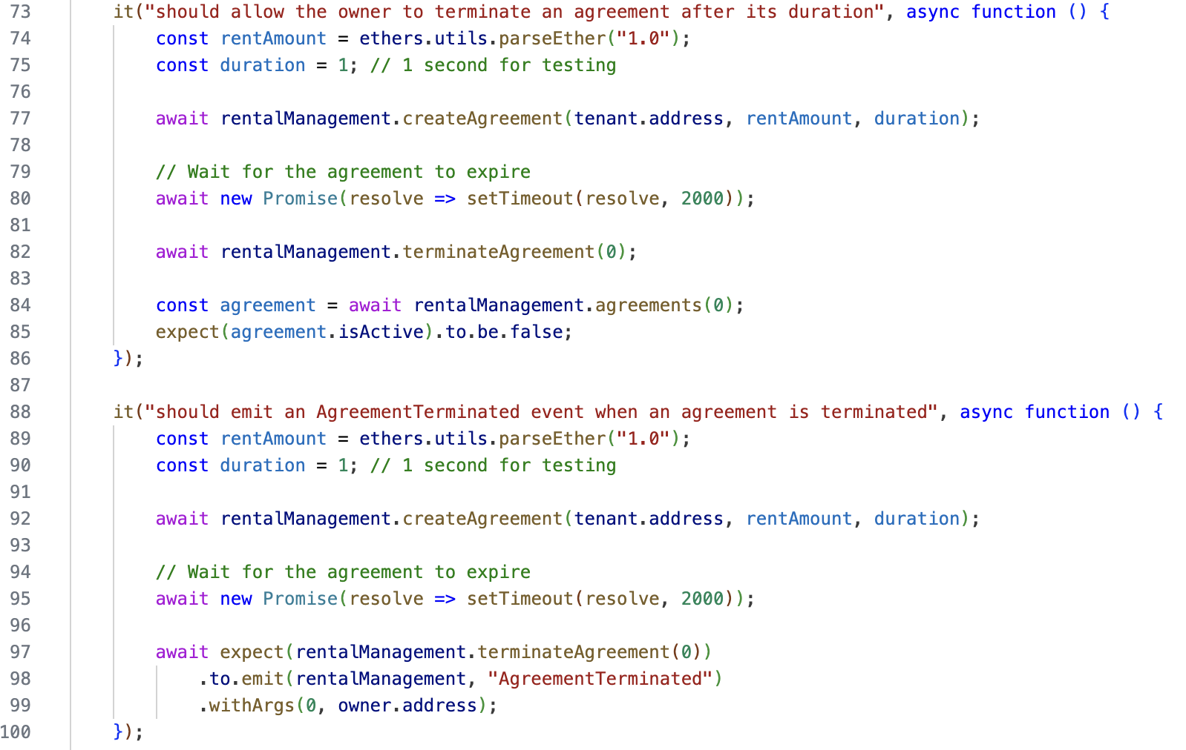

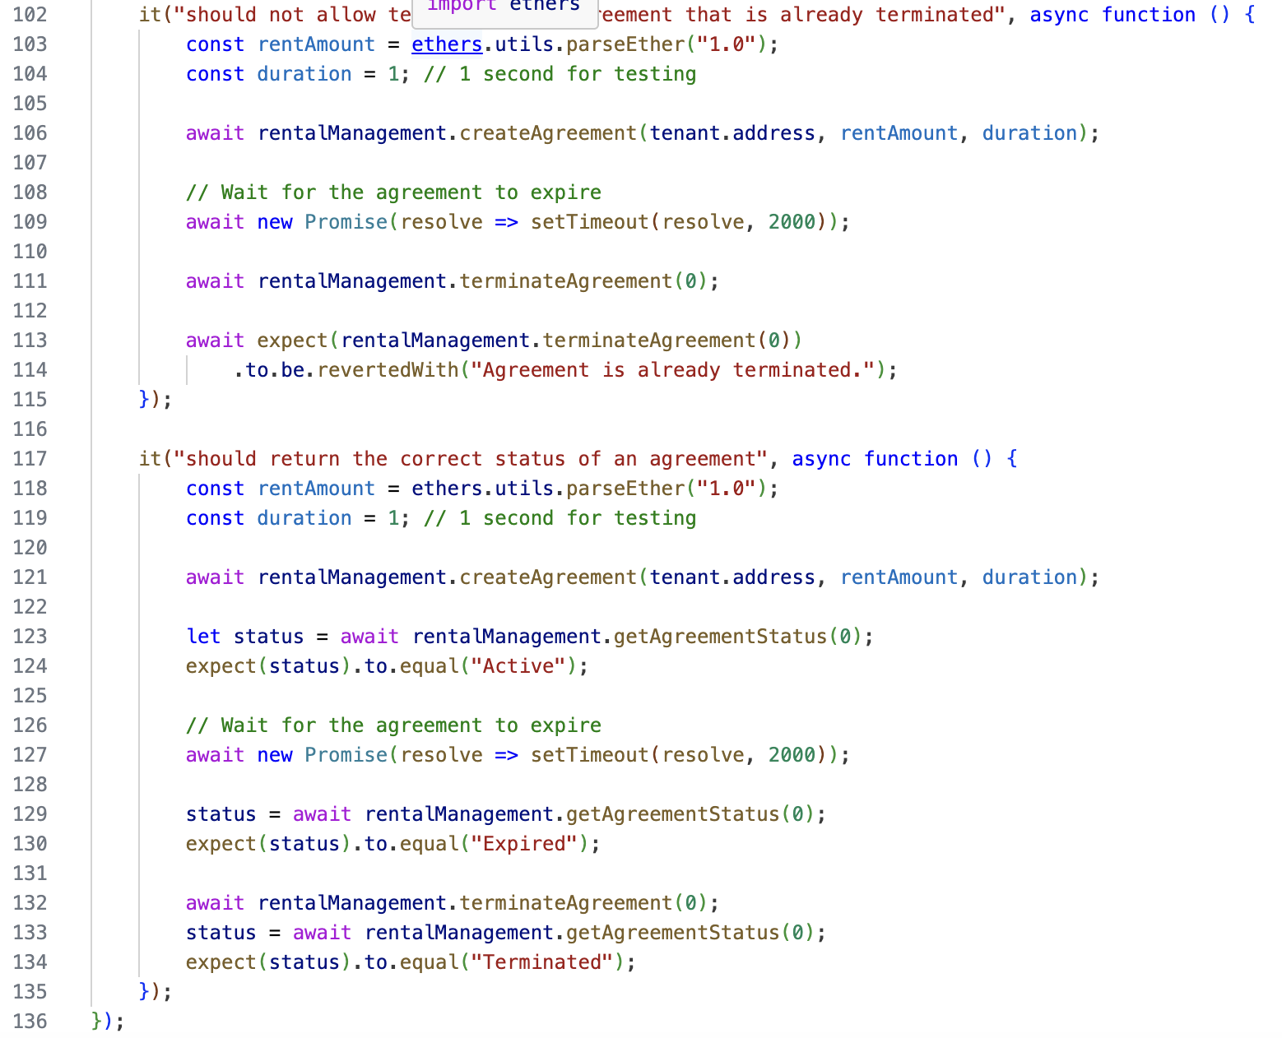

***Testing result for Q3:***

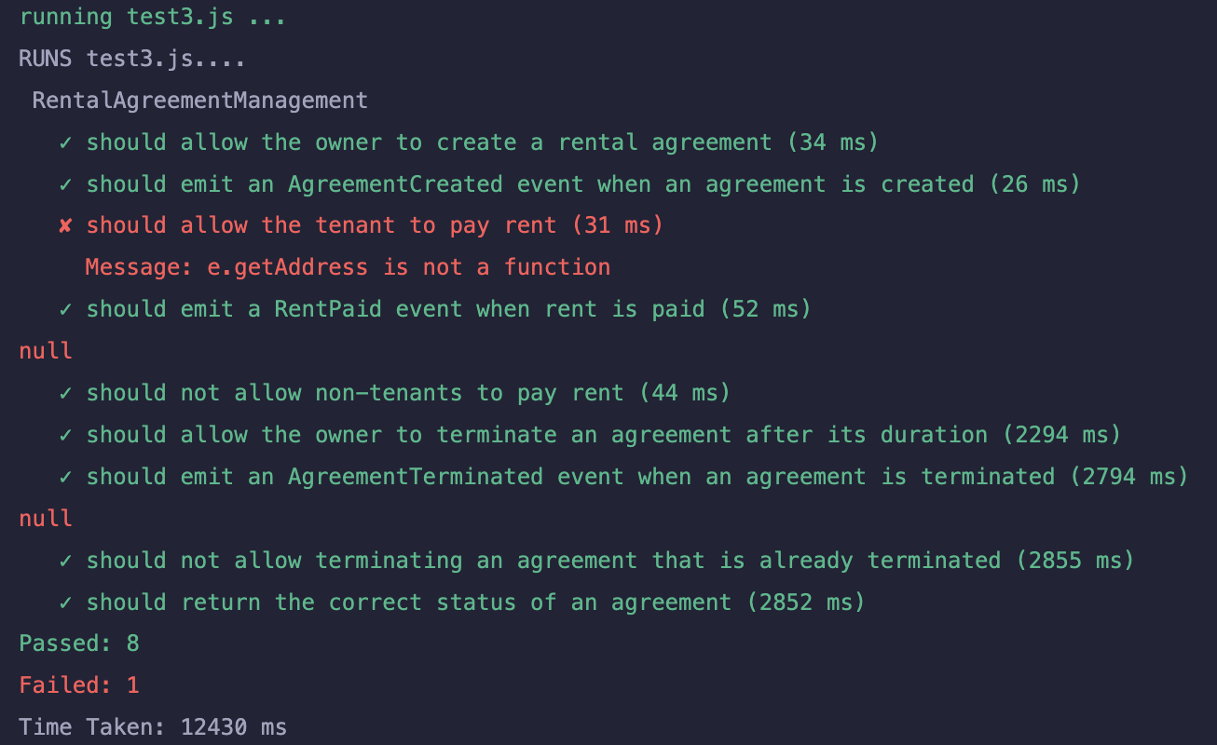

Solidity analyzers are used to verify DecentralizedCharityFund contract for vulnerabilities: 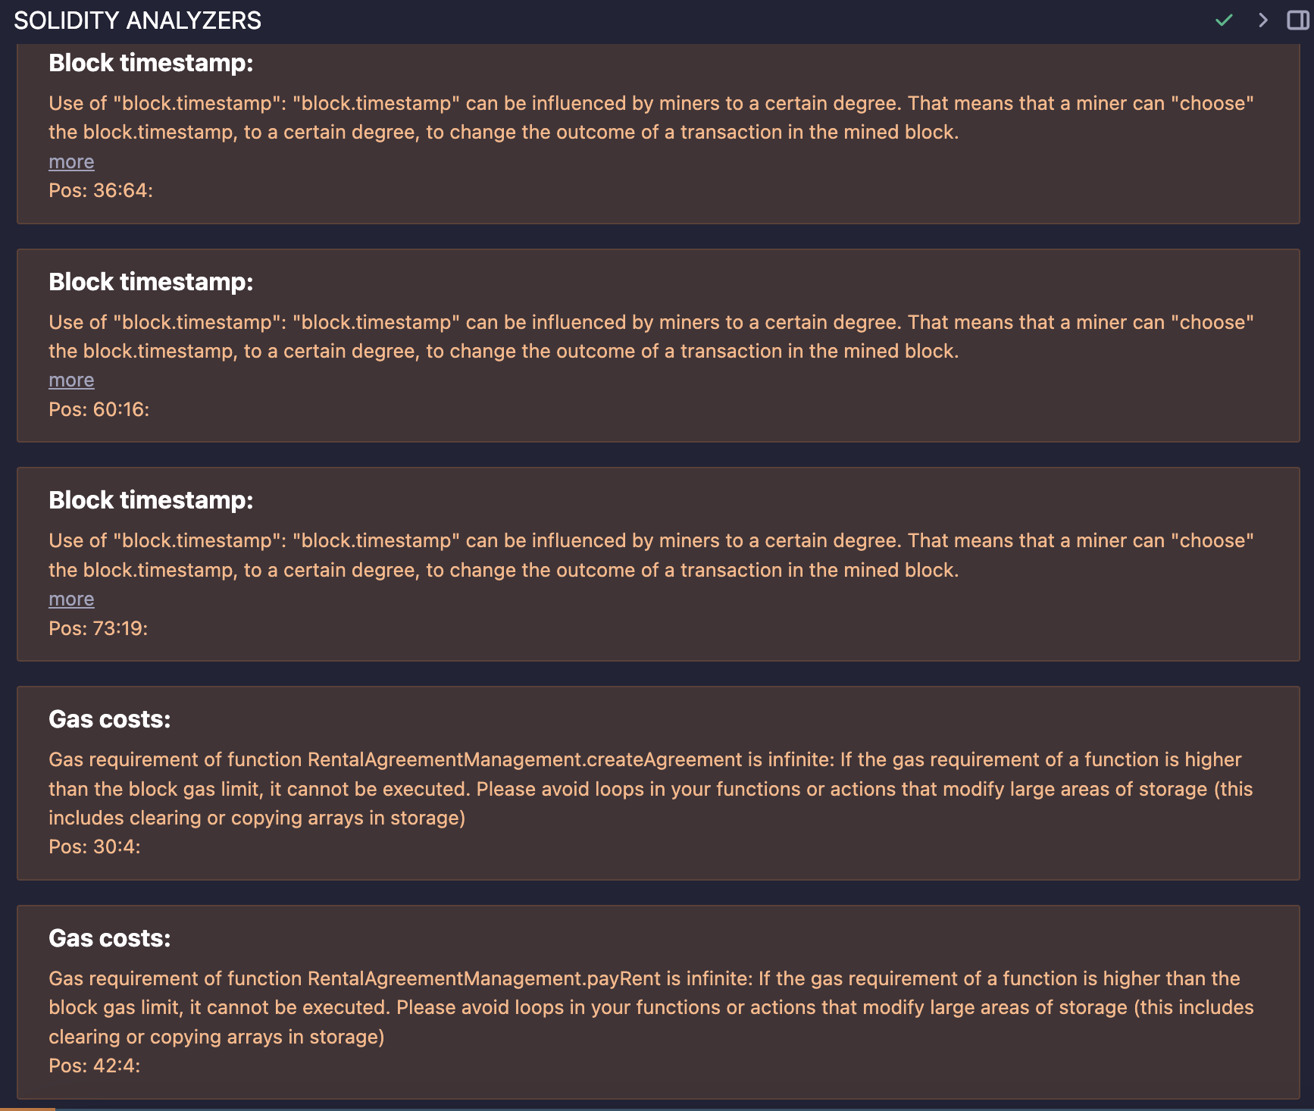

After deployment, the verified contract address: <https://sepolia.etherscan.io/address/0xbF7324BCFBc647960bf102Ba378B33CA0c8a3233>

***Testing codes for Q4:***

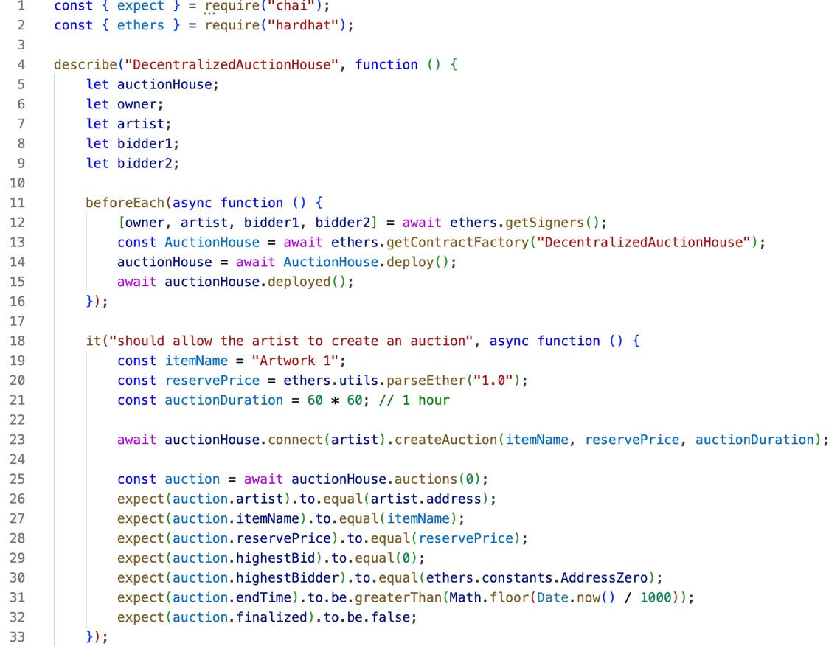

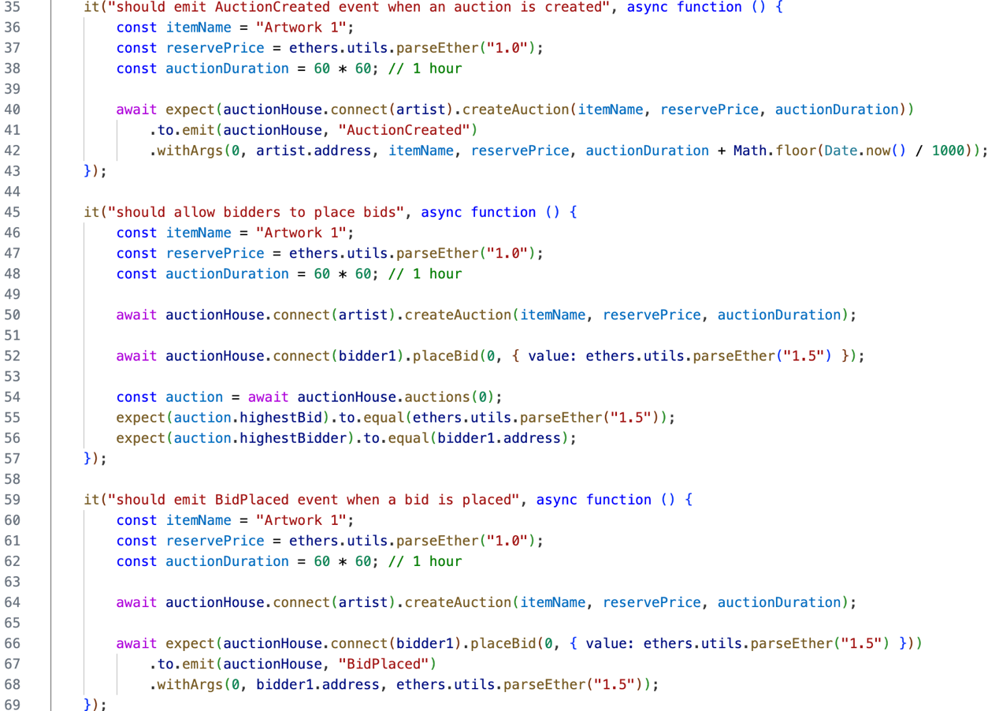

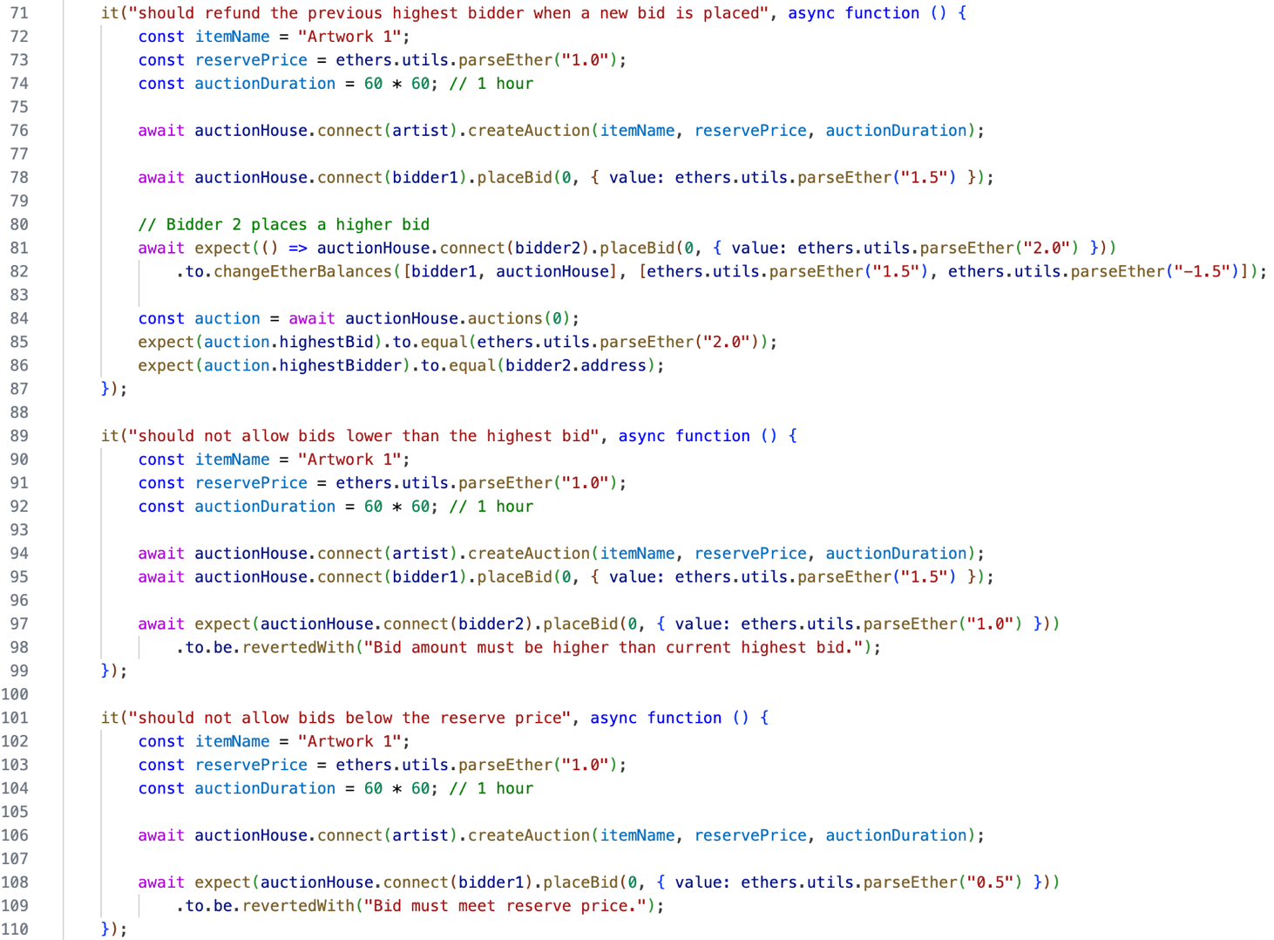

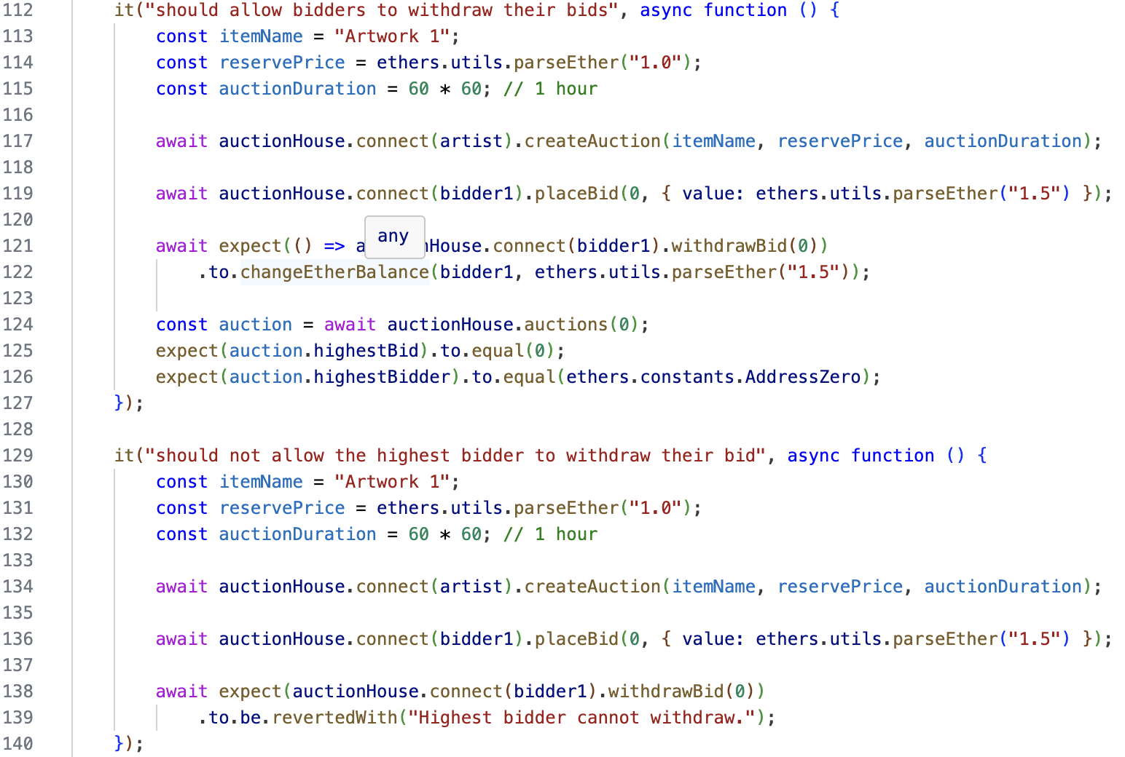

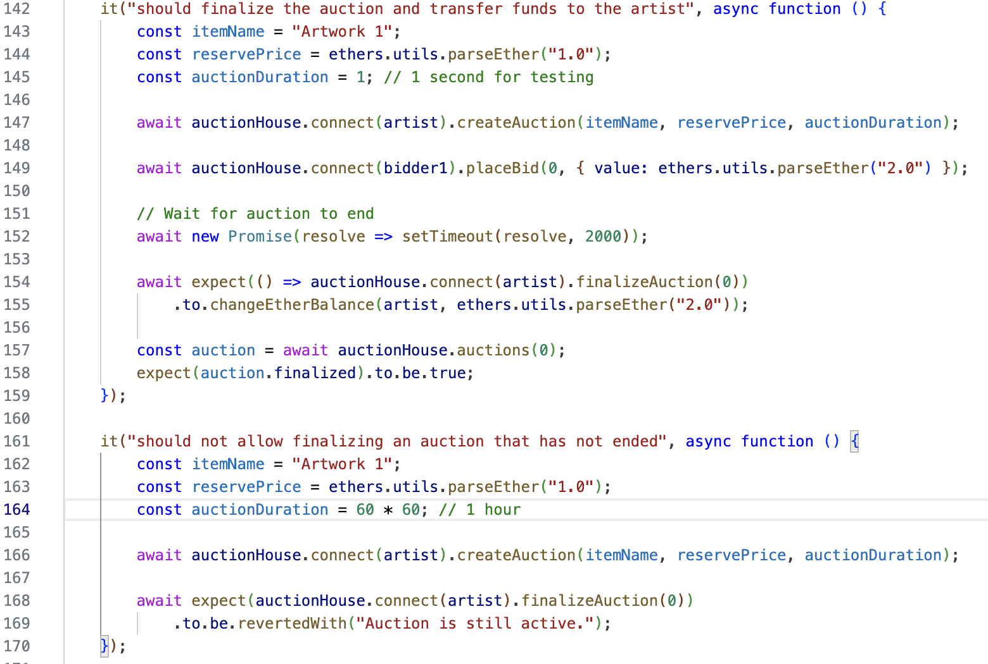

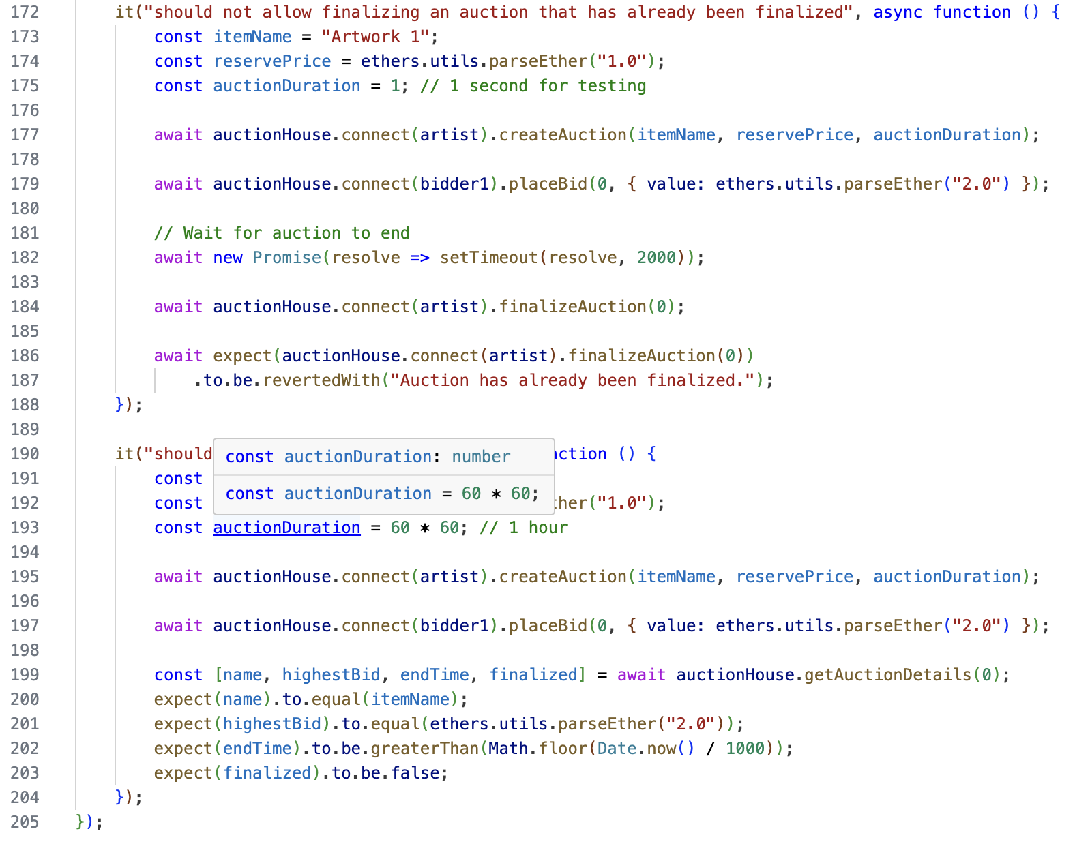

***Testing result for Q4:***

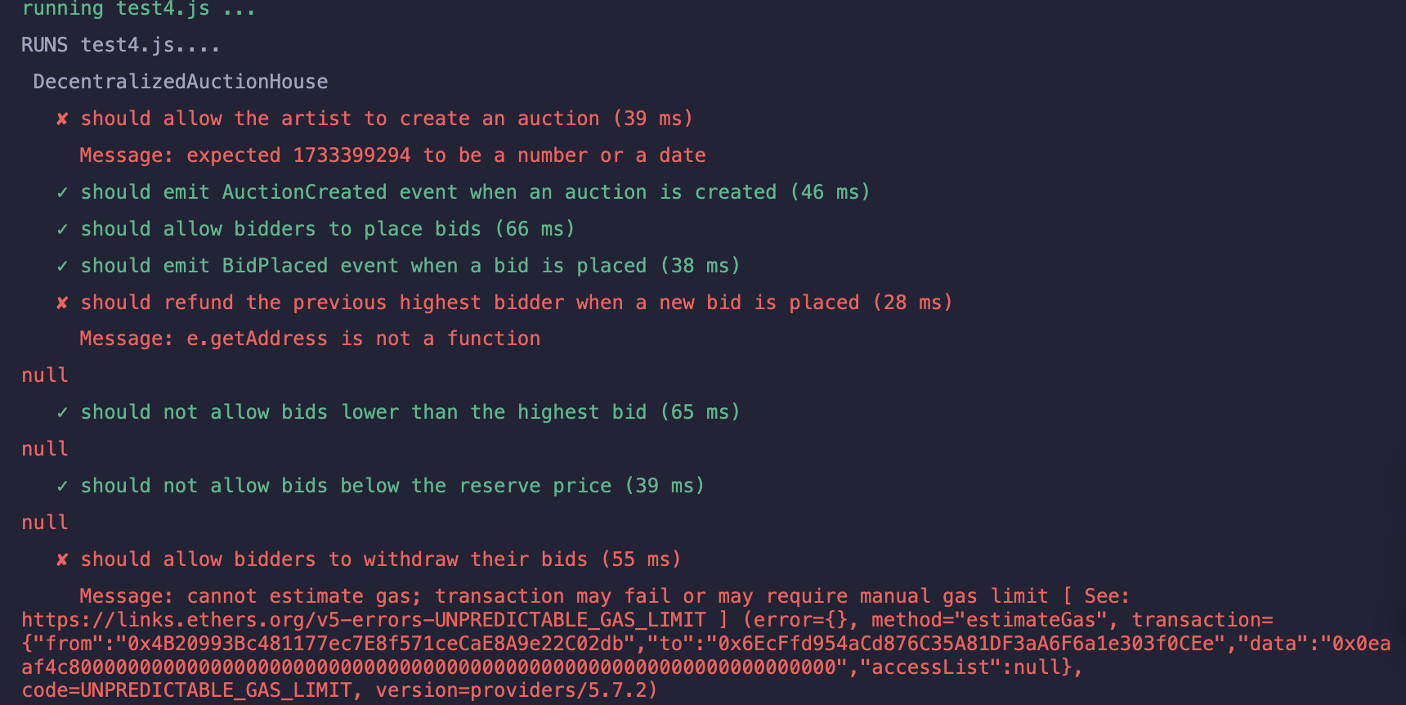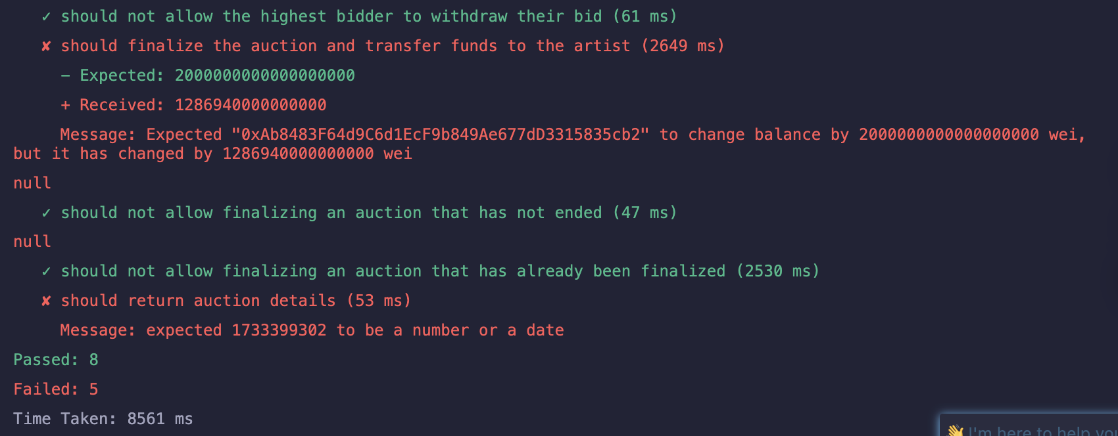

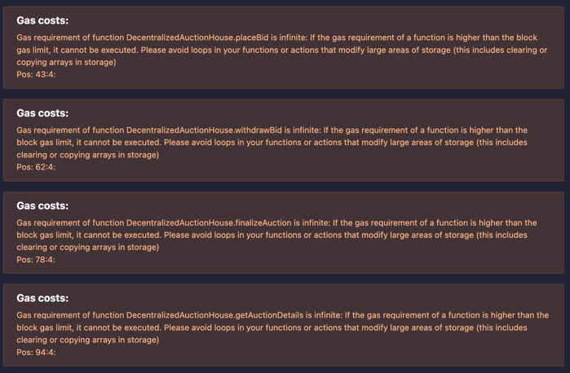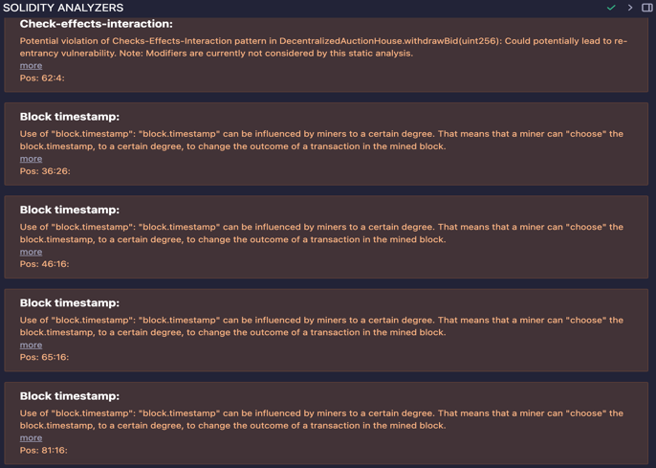Solidity analyzers are used to verify DecentralizedAuctionHouse contract for vulnerabilities:

After deployment, the verified contract address:

<https://sepolia.etherscan.io/address/0xc6da6c6A8C215ADBc521eeEd0C945D93F112Fd1e>

**P2**

**MZKKToken (ERC20)**

The MZKKToken will have the following features:

* **Minting**: Only the owner can mint new tokens.
* **Burning**: Token holders can burn their tokens.
* **Capped Supply**: The maximum supply is set to 1 million tokens.

**MZKKNFT (ERC721)**

The MZKKNFT will have the following features:

* **Minting with URI**: Each NFT will have a unique URI for metadata.
* **Transfer Restrictions**: Only the owner can mint new NFTs.
* **Royalty Payments**: The contract allows setting royalty fees for the original creator.

Before deploying, the vulnerabilities are detected as:

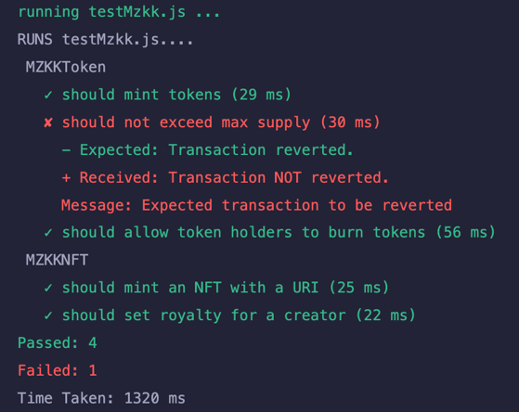

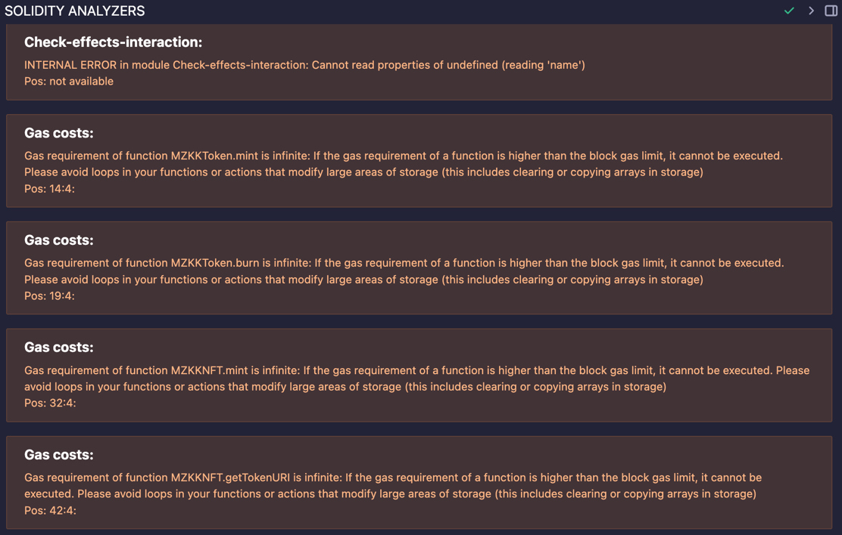Vulnerabilities:

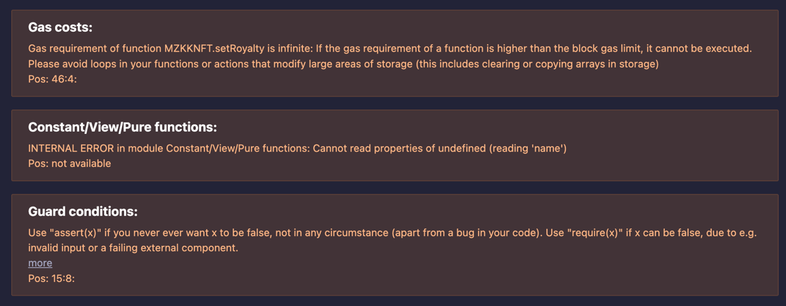

After deployment, the verified contract address is:

<https://sepolia.etherscan.io/address/0x84030698cb02D41796503b43a36f61F25422FFF5>